**Ozone Detection and Aerogel Particle Capture**

Ozone Detection

An increase in the number of factories and machines that emit greenhouse gases (GHGs) has caused the concentration of GHGs to rise steeply since the industrial era. These emissions create compounds that react with sunlight to form ozone, a GHG. Ozone not only traps heat in the atmosphere causing long-term global issues, but it also causes direct harm to both plants and animals. The damage that ozone causes to plants is due to plants taking the gas up through their stomata. Measuring ozone uptake has traditionally been a difficult and expensive process. This study proposes a novel approach towards measuring ozone uptake using a high-altitude balloon (HAB).

The HAB is cheap, quick, and can document carbon dioxide exchanges with agricultural crops over large spatial areas, hence to can ne used in ozone detection.

* This simplified version of the ozone formation process is shown below.

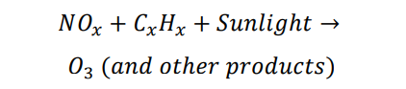

* Because 97 percent of the ozone molecules are located in the stratosphere with a maximum concentration at 26,000 meters above sea level, existing analysis methods are extremely expensive, time consuming, and inadequate. Moreover, atmospheric scientists are concerned with the possible further destruction of the ozone concentration due to the chemical contaminates released from presently existing ozone monitoring vehicles
* The methods of this experiment may involve launching a HAB carrying an ozone monitor and using the measured ozone concentrations to calculate ozone exchange values for each launch day.
* Ozonesondes are a collection of instruments contained in a small Styrofoam container, which measures ozone, temperature, relative humidity, pressure, and wind speed and direction from the surface to a height of 10 kilometres (6.2 miles) or higher.

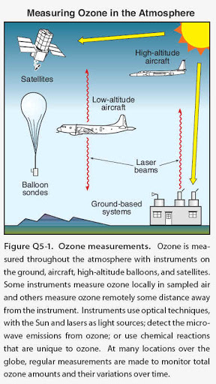

Aerogel Particle Capture

In order to collect particles without damaging them, one can use an extraordinary substance called ‘aerogel’. This is a silicon-based solid with a porous, sponge-like structure in which 99.8 percent of the volume is empty space. By comparison, aerogel is 1,000 times less dense than glass, which is another silicon-based solid. When a particle hits the aerogel, it buries itself in the material, creating a carrot-shaped track up to 200 times its own length. This slows it down and brings the sample to a relatively gradual stop. Since aerogel is mostly transparent - with a distinctive smoky blue cast - scientists will use these tracks to find the tiny particles.

Aerogel is not like conventional foams, but is a special porous material with extreme micro porosity on a micron scale. It is composed of individual features only a few nanometres in size. These are linked in a highly porous dendritic-like structure.

|  |
| --- |
| * The most notable application of silica aerogel in astronautics is to capture extra-terrestrial materials. This is primarily because it does not constitute elements of great cosmochemical significance as well as inorganic contaminants and secondly owing to its grandiosity in trapping particles with high velocities. * This exotic substance has many unusual properties, such as low thermal conductivity, refractive index and sound speed - in addition to its exceptional ability to capture fast moving dust. * Aerogel is made by high temperature and pressure-critical-point drying of a gel composed of colloidal silica structural units filled with solvents. |

|  |  |  |  |  |  |  |  |  |  |  |
| --- | --- | --- | --- | --- | --- | --- | --- | --- | --- | --- |
| The most successful aerogel-related mission that has unveiled many scientific discoveries is probably the Stardust Mission. Launched from the Kennedy Space Center in 1999, the function of the mission was to carry a hypervelocity particle collector which would meet up with a known outer solar system body (Comet 81P/Wild 2) to capture coma samples and interstellar dust to be brought on Earth for laboratory analysis   |  |  |  |  |  |  |  |  |  |  | | --- | --- | --- | --- | --- | --- | --- | --- | --- | --- | | |  |  |  |  |  |  |  |  |  | | --- | --- | --- | --- | --- | --- | --- | --- | --- | | |  |  |  |  |  | | --- | --- | --- | --- | --- | | |  |  | | --- | --- | |  |  | | Particle captured in Aerogel |  | | |  | |  | |  | | | |

Components Required: -

1. The payloads may be housed in insulated foam boxes/Styrofoam boxes. It may be wrapped in Al foil to provide the basic insulation, as well as radar reflection. Another way to provide better insulation would be to use- Kapton tape, which withstands a temperature down to -269 degrees Celsius.
2. Sensors
3. CO2 sensor [Measure CO₂ gas concentration]
4. Pressure [To measure the difference in pressure at that altitude, and on ground]
5. Temperature [To measure the temperature, and compare with the temperature on land.]
6. Altitude [To know, at what altitude the ozone detection is taking place]
7. Ozone sensor [Measure O₃ gas concentration]
8. Battery(s) (Lightweight), 9-Volt
9. Controller Board- Arduino, Arduino Battery
10. Linear Actuator [To maintain centre of mass of the payload, and ensure greater stability]
11. 2 Cameras [To click images of the surroundings as seen from the payload at high-altitude.]
12. Telemetry unit – (APRS Tracker, GPS Receiver)
13. Silica Aerogel

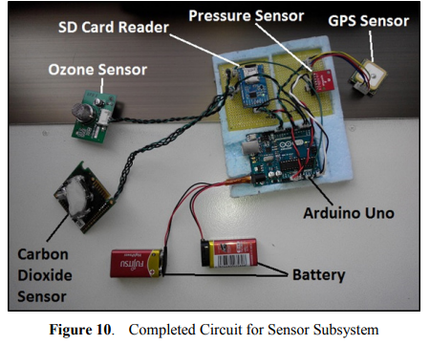

References and additional sources-

1. <https://mde.state.md.us/programs/Air/AirQualityMonitoring/Pages/Balloon.aspx>
2. <https://via.library.depaul.edu/cgi/viewcontent.cgi?referer=https://www.google.com/&httpsredir=1&article=1088&context=depaul-disc>
3. <https://ntrs.nasa.gov/archive/nasa/casi.ntrs.nasa.gov/19900015791.pdf>
4. <http://www.hrpub.org/download/20180630/EER7-14011153.pdf>
5. <https://stardust.jpl.nasa.gov/tech/aerogel.html>